CSCI 400 Lab 2

**Name: Christopher Gonzalez**

**Class Section: CSCI 400 02 [35583]**

**Date: September 19, 2024**

**Instructions**:

* Login to your account at <https://pwn.college/>

**pwn.college username: Chris_B_Gonzalez**

* Go to the Linux Luminarium dojo: <https://pwn.college/linux-luminarium/>
* Complete the challenges in Commands: <https://pwn.college/linux-luminarium/commands/>

**Challenge 1: cat: Not the Pet, But the Command!**

**To attain this flag, I started the challenge and opened the terminal. The instructions for this challenge informed me that the flag file was copied to my home directory. Therefore, I would be allowed to read the contents of the file using the cat command. I proceeded by entering “cat flag” into the terminal, and the flag was revealed to me which is highlighted in white.**

**Challenge 2: Catting Absolute Paths**

**To attain this flag, I started the challenge and opened the terminal. This challenge is almost identical to the previous challenge, but the main difference was the location of the flag file. This time, the flag file was not in my home directory, meaning I would need to access it using its absolute path. The absolute path of the flag file was /flag, so, I entered the command “cat /flag” which revealed the flag.**

**Challenge 3: More Catting Practice**

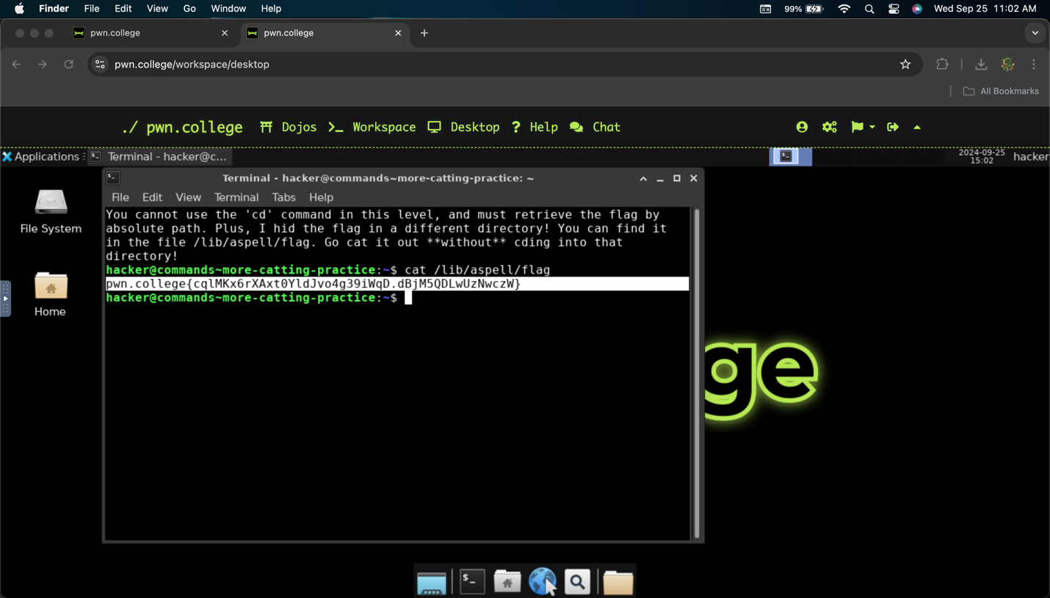

**To attain this flag, I started the challenge and opened the terminal. Upon opening the terminal, I was informed that I wouldn’t be allowed to use the cd command. This is significant to the challenge because the flag file was not in my home directory, meaning I had to discover a way to access the file withing using the cd command. Fortunately, the terminal provided the absolute path of the file (/lib/aspell/flag). With this information, I can access the using by entering “cat /lib/aspell/flag” and so the flag was obtained.**

**Challenge 4: Grepping for a Needle in a Haystack**

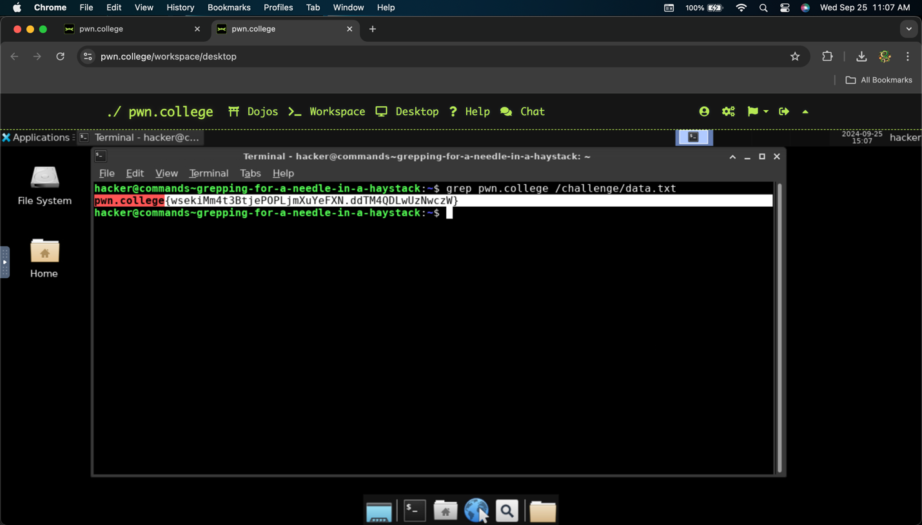

**To attain this flag, I started the challenge and opened the terminal. The instructions for the challenge introduced me to the grep command, which can be used to search for specific phrases in a given file. I was also informed the absolute path of the file containing the flag (and a hundred thousand lines of text) was /challenge/data.txt, so I proceeded to enter in the terminal “grep pwn.college /challenge/data.txt”. This command had the terminal look into the file for any lines containing the phrase “pwn.college”, and the output was the flag.**

**Challenge 5: Listing Files**

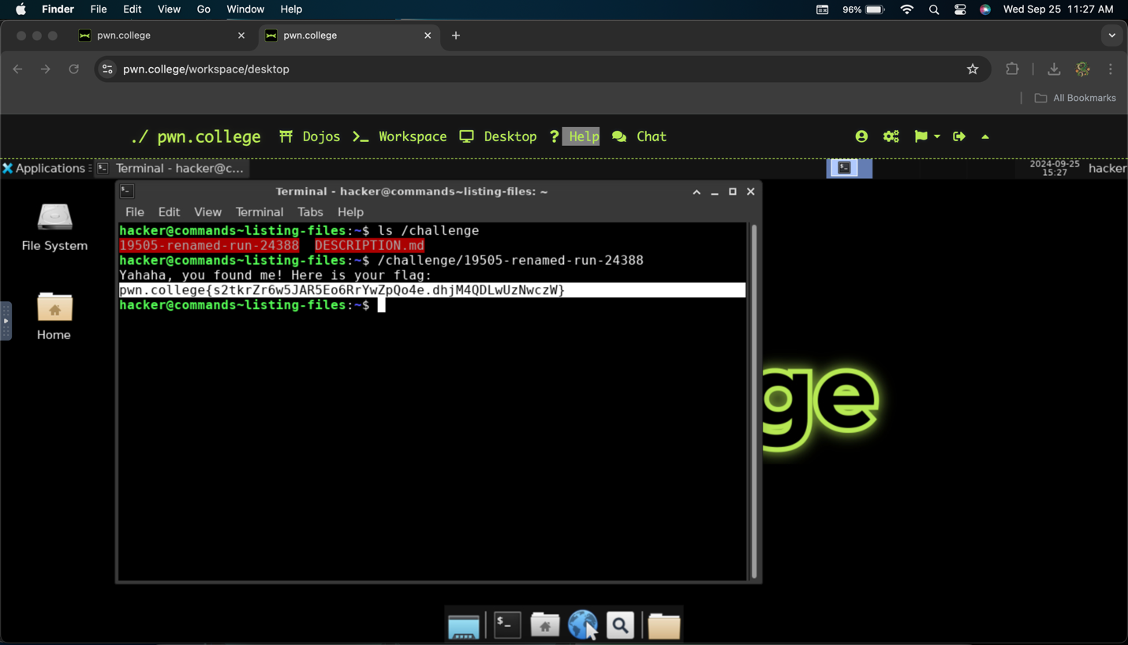

**To attain this flag, I started the challenge and opened the terminal. The instructions for the challenge informed me to use the ls command, which lists all files in a given directory. Since the flag is in /challenge, I entered “ls /challenge” to see all files in the directory. The output (highlighted in red) indicates that the flag file was renamed as so: 19505-remanmed-run-24388. Now that I knew the name of the file, I was able to execute it by entering “/challenge/19505-remanmed-run-24388” and the flag was given to me. Admittedly, I had first attempted to read the file using cat, but to no avail. I didn’t learn until later that I should have been trying to execute the file rather than reading it.**

**Challenge 6: Touching Files**

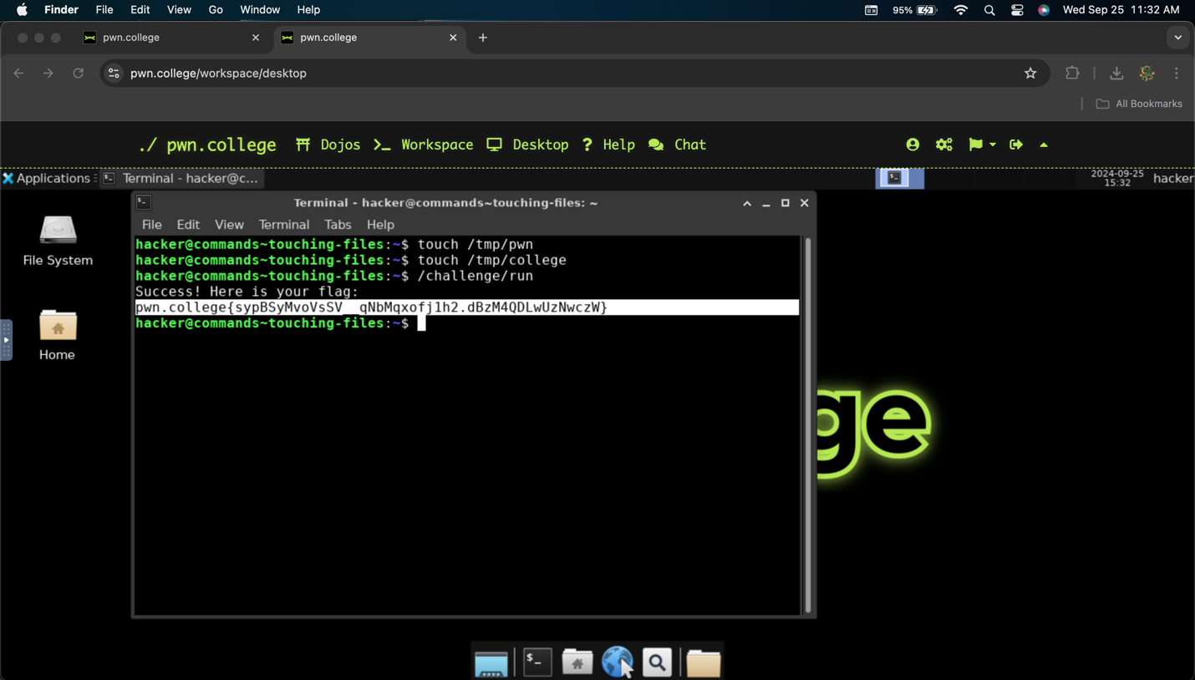

**To attain this flag, I started the challenge and opened the terminal. The instruction for the challenge introduced me to the touch command, which can be used to create blank files on the machine. I was instructed to create two files: /tmp/pwn and /tmp/college prior to accessing the flag. I created the files by entering “touch /tmp/pwn” and then “touch /tmp/college”. After this, I ran /challenge/run which gave me the flag.**

**Challenge 7: Removing Files**

**To attain this flag, I started the challenge and opened the terminal. The instructions for this challenge asked me to first create the file delete_me. I proceeded to do this by entering “touch delete_me” which effectively created the file. Then, I was asked to remove the file using the rm command. I removed the file by entering “rm delete_me” in the terminal, which deleted the file I had created for the challenge. Finally, I was instructed to execute /challenge/check which would verify that I created and deleted the delete_me file correctly. Since I did it correctly, I was given the flag.**

**Challenge 8: Hidden Files**

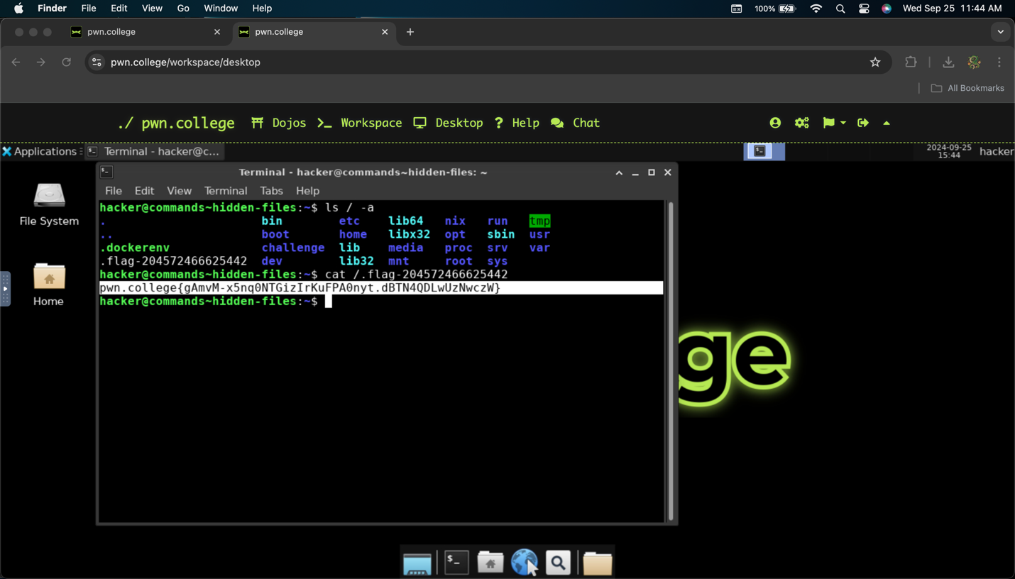

**To attain this flag, I started the challenge and opened the terminal. The instructions for this challenge informed me that the ls command does not list all files in a directory by default. Any files that begin with a “.” will not be seen usings ls alone. To view files that begin with a “.”, I have to use the -a option. I was also informed the file was in the / directory, so I entered “ls / -a” to look at all files beginning with a “.”. I discovered the flag file was named .flag-204572466625442, so I then entered “cat /.flag-204572466625442” to obtain the flag.**

**Challenge 9: An Epic Filesystem Quest**

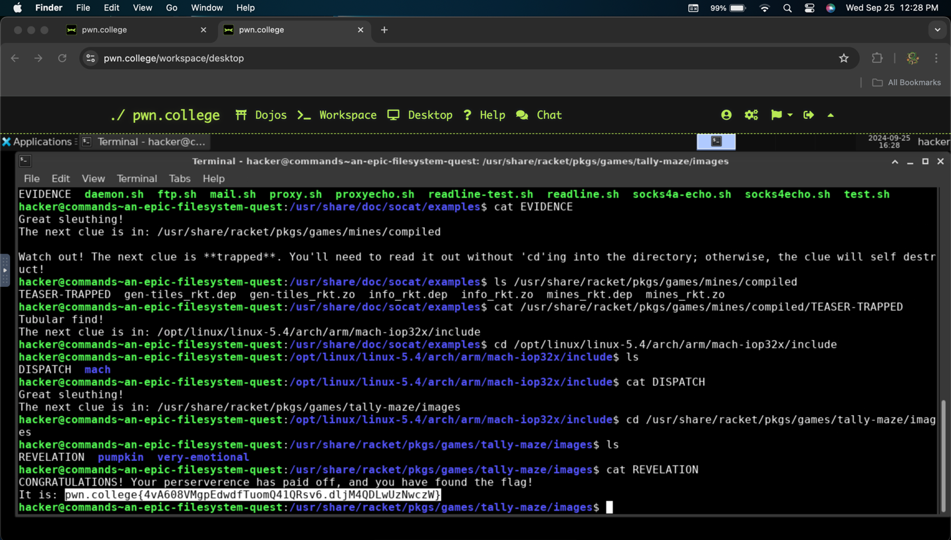

**To attain this flag, I started the challenge and opened the terminal. As the name implies, the work required to get the flag was a long quest. In short, the quest is designed for the user to use a combination of cd, ls, and cat to track clues hidden in the machine to eventually reach the flag. For simplicity purposes, I will list the steps I had to do in order:**

* **Use cd to reach the /directory**
* **Use ls to determine the next clue (it was labeled as “SECRET”)**
* **Read the contents of SECRET using cat**
* **Use ls -a option to look for the next clue in /opt/linux/linux-5.4/include/config/i8253**
* **Use cat to access the file (named “.CUE”)**
* **Use ls to look at the content in /usr/share/racket/pkgs/htdp-lib/asl/lang/compiled (using cd would cause the clue to self-destruct)**
* **Use cat to open the next clue (named “GIST-TRAPPED”)**
* **Use cd to reach /opt/radare2/libr/arch/p/cris/gnu so the clue will become readable**
* **Use ls to look at the contents in the directory**
* **Use cat to open the next clue (named “README”)**
* **Use ls to look at /opt/busybox/busybox-1.33.2/include/config/feature/show (using cd will cause the clue to self-destruct)**
* **Use cat to open the next clue (named “SNIPPET-TRAPPED)**
* **Use cd to reach /usr/share/doc/socat/exampes to the clue will become readable**
* **Use ls to list the contents in the directory**
* **Use cat to open the next clue (named “EVIDENCE”)**
* **Use ls to look at /usr/share/racket/pkgs/games/mines/compiled (using cd will cause the clue to self-destruct)**
* **Use cat to open the next clue (named “TEASER-TRAPPED”)**
* **Use cd to reach /opt/linux/linux-5.4/arch/mach-iop32x/include**
* **Use ls to look at the contents in the directory**
* **Use cat to open the next clue (named “DISPATCH”)**
* **Use cd to reach /usr/share/racket/pkgs/games/tally-maze/images**
* **Use ls to look at the contents in the directory**
* **Use cat to open the next clue (named “REVELATION”), where the flag was located.**

**Challenge 10: Making Directories**

**To attain this flag, I started the challenge and opened the terminal. The instructions for this challenge introduced me to the mkdir command, which creates a directory with the name specified by the user. I was instructed to use mkdir to make a directory named /tmp/pwn, which I did by entering “mkdir /tmp/pwn”. Then, I used the touch command learned previously to make a file in the new directory called “college”. Finally, I ran /challenge/run so the terminal can check my work. Because I performed correctly, I was given the flag.**

**Challenge 11: Finding Files**

**To attain this flag, I started the challenge and opened the terminal. The instructions for this challenge introduced me to the find command which can be used to look for files based on their name and/or directory. Initially, I entered “find / -name flag”, but this resulted in over 100 different matches, most of which were denied for me to look at. With some minor assistance from SENSAI, I modified the original command and included “2>/dev/null” at the end. This extension reduced all possibilities seen before to just 7. Unfortunately, I was required to manually check each option using the cat command. Upon using the cat command on the third absolute path (/usr/share/perl/5.30.0/Math/BigInt/flag), the flag information was revealed to me.**

**Challenge 12: Linking Files**

**To attain this flag, I started the challenge and opened the terminal. The instructions for this challenge introduced me to the ln -s command, which is used to link a file for two different locations. In the description, I was asked to link /flag to /challenge/catflag. However, the problem was that /challenge/catflag will read the contents of /home/hacker/not-the-flag. To resolve this problem, I used ln -s to link /flag to /home/hacker/not-the-flag since /challenge/catflag reads the contents stored here. After linking the two locations, I tried executing /challenge/catflag which should now be reading the contents of /flag rather than not-the-flag. After running this, it was revealed I linked the two locations correctly and was given the flag.**